BOOTSTRAP

Introduction :
Bootstrap 5 is the newset version of Bootstrap, which is the most popular HTML, CSS, and JavaScript framework for creating responsive, mobile-first websites .

Bootstrap 5 Get Started :

What is Bootstrap ?
- Bootstrap is a free front-end framework for faster and easier web development .
- Bootstrap includes HTML and CSS based design templates for typography, forms, buttons , tables , navigation , modals , image careousels and many other, as well as optional javascript plugings .
- Bootstrap also gives you the ability to easily create responsive desings
Note :
Responsive web design is about creating web sites which automatically adjust themselves to look good on all devices, from small phones to large desktops.

Bootstrap Versions
Bootstrap 5 (released 2021) is the newest version of Bootstrap (released 2013); with new components, faster stylesheet and more responsiveness .
The main differences between Bootstrap 5 and Bootstrap 3 & 4, is that bootstrap5 has switched to vanillla javascript instead of jQuery .
Note :
Bootstrap 3 and bootstrap 4 is still supported .

Why use Bootstrap ?
- Increase developemnt speed
- Assure responsiveness
- Prevent repetition between projects
- Add consitency ensure cross browser compatibility
- Large community
- Customizable

Where to Get Bootstrap 5 ?
There are two 2 to strat using Bootstrap 5 on your own web site .
You can :
- Include Bootstrap 5 from a CDN
- Dowload Bootstrap 5 from getbootstrap.com

Bootstrap 5 CDN
If you don’t want to download and host bootstrap 5 yourself, you can include it from a CDN (Content Delivery Network).
jsDelivr provides CDN support for Bootstrap’s css and js .
<!-- Latest compiled and minified CSS -->
<link href="https://cdn.jsdelivr.net/npm/bootstrap@5.3.3/dist/css/bootstrap.min.css" rel="stylesheet">
<!-- Latest compiled JavaScript -->
<script src="https://cdn.jsdelivr.net/npm/bootstrap@5.3.3/dist/js/bootstrap.bundle.min.js"></script>

One advantage of using the bootstrap 5 CDN :
Many users already have downloaded Bootstrap 5 from jsDelivr when visiting another site. As a result, it will be loaded from cache when they visit your site, which leads to faster loading time. Also, most CDN’s will make sure that once a user requests a file from it, it will be served from the server closest to them , which also leads to faster loadng time.
Javascript?
Bootstrap 5 uses JavaScript for different components (like modals, tooltips, popovers etc). However, if you just use the CSS part of Bootstrap, you don't need them.

Downloading Bootstrap 5
If you want to download and host bootstrap 5 yourself go to https://getbootstrap.co/
And follow the instruction there.

Package managers
Npm : install in your node.js powered apps with the npm package :
npm install bootstrap

Bootstrap 5 Containers :
You learned from the previous chapter that bootstrap requires a containing element to wrap site contents .
Containers are used to pad the content inside of them, and there are 2 container classes available :
- The .container class provides a responsive fixed width container .
- The .container-fluid class provides a full width container, spanning the entire width of the viewport
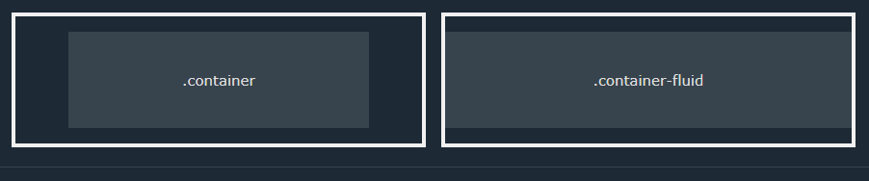

Fixed Container
Use the .container class to create a responsive, fixed-width container .
Note that its width (max-width) will change on different screen sizes :
 | Extra small <576px | Small >=576px | Medium >= 768px | Large >=992px | Extra Large >=1200px | XXL >= 1400px
max-width | 100% | 540px | 720px | 960px | 1140px | 1320px
Tip :
The XXL breakpoint (>= 1400px) is new in Bootstrap 5, while the largest breakpoint in Bootstrap 4 is Extra large (>=1200px=

Fluid Container
Use the .container-fluid class to create a full width container, that will always span the entire with of screen ( width is always 100% ) .

Container Padding
By default, containeres have left and right padding, with no top or bottom padding. Therefore, we oftern use spacing utilities such as extra padding and margins to make them look even better. For example , .pt-5 means “add a large top padding”

Container Border and color
Other utilities, such as borders and colors, are also often used together with containers :
<div class="container p-5 my-5 border">
<h1>My first bootstrap Page</h1>
<p>This container has a border and some extra padding</p>
</div>
<div class="container p-5 my-5 bg-dark text-white">
<h1>My first bootstrap Page</h1>
<p>This container has a border and some extra padding</p>
</div>
<div class="container p-5 my-5 bg-warning">
<h1>My first bootstrap Page</h1>
<p>This container has a border and some extra padding</p>
</div>
<div class="container p-5 my-5 bg-primary text-white">
<h1>My first bootstrap Page</h1>
<p>This container has a border and some extra padding</p>
</div>

In This case , my-5 adds a margin of 3rem (48px == 16*3) to the top and bottom of the element .
Here’s the breakdown :
- M stands for “margin”
- Y stands for “y-axis” (top and bottom)
- 5 represent the size of the margin, which is 3rem in this case
So my-5 is equivalent to adding the following CSS syles :
margin-top: 3rem;
margin-bottom: 3rem;
Note :
In Bootstrap 5, the spacing scale actually goes up to 10:
- 0: 0rem (0px)
- 1: 0.25rem (4px)
- 2: 0.5rem (8px)
- 3: 1rem (16px)
- 4: 1.5rem (24px)
- 5: 3rem (48px)
- 6: 4.5rem (72px)
- 7: 6rem (96px)
- 8: 8rem (128px)
- 9: 10rem (160px)
- 10: 12rem (192px)

Responsive Containers
You can also use the .container-sm|md|lg|xl classes to determine when the container should be responsive.
The max-width of the container will change on different screen sizes/viewports 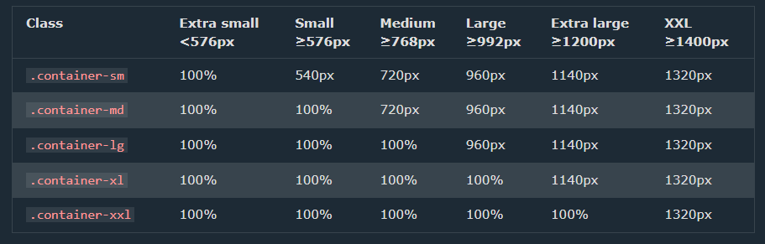

Bootstrap 5 Grid System
Bootstrap’s grid system is built with flexbox and allows up to 12 columns across the page .
If you do not want to use all 12 column individually, you can group the columns together to create wider columns :
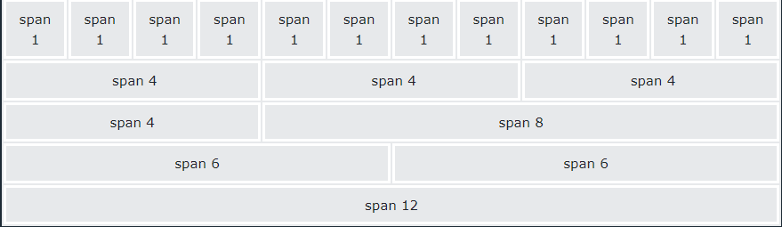
The grid system is responsive, and the column will re-arrange automatically depending on the screen size.
Make sure that the sum adds up to 12 or fewer (It not required that you use all 12 available columns).

Grid Classes
The Bootstrap 5 grid system has six classes :
- .col- (extra small devices – screen width less than 576px)
- .col-sm- (small devices – screen width equal to or greater than 576px)
- .col-md- (medium devices – screen width equal to or greater thatn 992px)
- .col-lg- (xlarge devices – screen with equal to or greater than 1200px)
- .col-xxl- (xxlarge devices – screen width equal to or greater than 1400px ) .
The classes above can be combined to create more dynamic and flexible layouts.
Tip : Each class sclales up, so if you want to set the same widths for sm and md, you only need to specify sm .
First example : create a row ( <div class=”row”> ). Then, add the desired number of columns (tags with approriate .col-*-* classes). The first star (*) represents the responsiveness: sm, md, lg, xl or xxl, while the second star represents a numberv which schould add up to 12 for each row.
<div class="container-fluid mt-3">
<h1>Two Unequal Responsive Columns</h1>
<p>Resize the browser window to see the effect.</p>
<p>
The columns will automatically stack on top of each other when the
screen is less than 576px wide.
</p>
<div class="row">
<div class="col-sm-4 p-3 bg-primary text-white">.col</div>
<div class="col-sm-8 p-3 bg-dark text-white">.col</div>
</div>
</div>

Second example : instead of adding a number to each col, let bootstrap handle the layout, to create equal width columns: two “col” elements = 50% width to each col,

<div class="container">
<div class="row text-white bg-primary border">
<div class="col border">1</div>
<div class="col border">2</div>
<div class="col border">3</div>
</div>
</div>
while three cols = 33.33% width to each col. Four cols = 25% width, etc. you can also use .col-sm|md|lg|xl|xxl to make the columns responsive.

Bootstrap 5 Text / typography
Bootstrap 5 uses a default font-size of 1rem ( 16px by default ), and its line-height is 1.5
In addition, all <p> elements have margin-top: 0 and margin-bottom: 1rem

<h1> - <h6>
Bootstrap 5 styles HTML heading (<h1> to <h6> ) with a bolder font-weight and a responsive font-size. 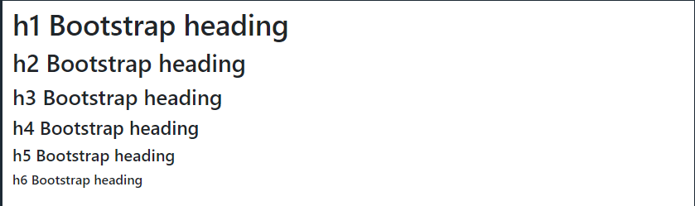
You can also use .h1 to .h6 classes on other elements to make them behave as headings if you want :
<p class="h1">h1 Bootstrap heading</p>
<p class="h2">h2 Bootstrap heading</p>
<p class="h3">h3 Bootstrap heading</p>
<p class="h4">h4 Bootstrap heading</p>
<p class="h5">h5 Bootstrap heading</p>
<p class="h6">h6 Bootstrap heading</p>
The heading classes in Bootstrap are used to style headings (h1-h6 elements). They are used to define the font size, weight, and line height of headings. The available heading classes in Bootstrap are:
- .h1 (font size: 36px, font weight: 500)
- .h2 (font size: 30px, font weight: 500)
- .h3 (font size: 24px, font weight: 500)
- .h4 (font size: 18px, font weight: 500)
- .h5 (font size: 14px, font weight: 500)
- .h6 (font size: 12px, font weight: 500)

Display Headings
Display headings are used to stand out more than normal headings (larger font-size and lighter font-weight), and there are six classes to choose from :
.display-1 to .display-6
<div class="container mt-3">
<h1>Display Headings</h1>
<p>
Display headings are used to stand out more than normal headings (larger
font-size and lighter font-weight):
</p>
<h1 class="display-1">Display 1</h1>
<h1 class="display-2">Display 2</h1>
<h1 class="display-3">Display 3</h1>
<h1 class="display-4">Display 4</h1>
<h1 class="display-5">Display 5</h1>
<h1 class="display-6">Display 6</h1>
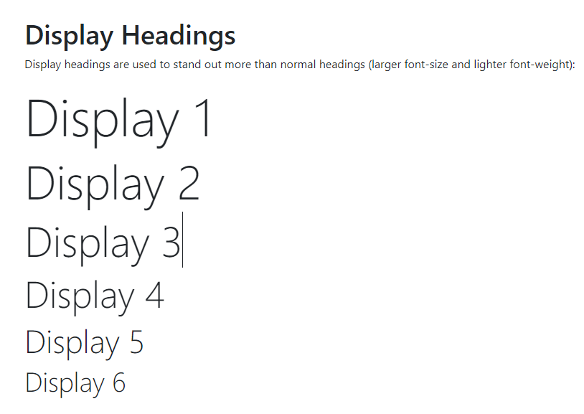
</div>

<small>
In Bootstrap 5 the HTML <small> element (and the .small class) is used to create a smaller, secondary text in any heading

<mark>
Bootstrap 5 will style <mark> and .mark with a yellow background color and some padding

<abbr>
Bootstrap 5 will style the HTML <abbr> element with a dotted border bottom and a cursor with question mark on hover:

<blockquote>
Add the .blockquote class to a <blockquote> when quoting blocks of content from another source. And when namang a source, like “from WWF’f website”, use the .blockquote-footer class :
<div class="container mt-3">
<h1>Blockquotes</h1>
<p>
The blockquote element is used to present content from another source:
</p>
<blockquote class="blockquote">
<p>
For 50 years, WWF has been protecting the future of nature. The
world's leading conservation organization, WWF works in 100 countries
and is supported by 1.2 million members in the United States and close
to 5 million globally.
</p>
<footer class="blockquote-footer">From WWF's website</footer>
</blockquote>
</div>
Result :
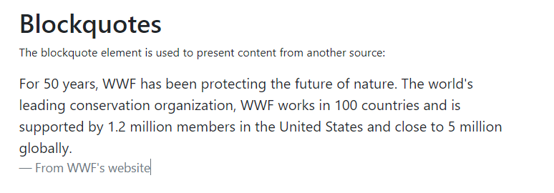

<dl>
Bootstrap 5 will style the HTML <dl> element in the following way :

<code>
Bootstrap 5 will style the HTML <code> element in the follwing way :

<kbd>
Bootstrap 5 will style the HTML <kbd> element in the following way :
<div class="container mt-3">
<h1>Keyboard Inputs</h1>
<p>
To indicate input that is typically entered via the keyboard, use the
kbd element:
</p>
<p>Use <kbd>ctrl + p</kbd> to open the Print dialog box.</p>
</div>
And it looks like this :
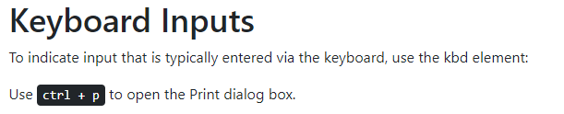

<pre>
Bootstrap 5 will style the HTML <pre> element in the following way :
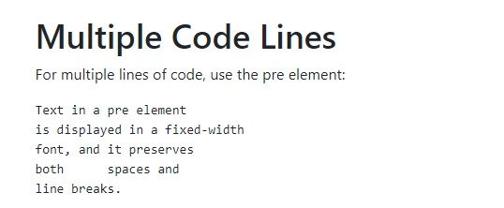

More Typography Classes
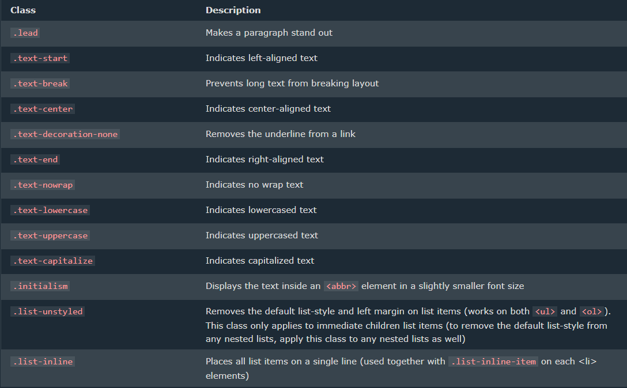
The bootstrap 5 classes below can be added to syle HTML elements :

BS 5 Colors

Text Colors
Bootstrap 5 has some contextual classes that can be used to provide “meaning through colors”.
The classes for text colors are : .text-muted, .text-primary, .text-success, .text-info , .text-warning, .text-danger, .text-secondary, .text-white, .text-dark, .text-body (default body color / often black) and .text-light :
<div class="container mt-3">
<h2>Contextual Colors</h2>
<p>Use the contextual classes to provide "meaning through colors":</p>
<p class="text-muted">This text is muted.</p>
<p class="text-primary">This text is important.</p>
<p class="text-success">This text indicates success.</p>
<p class="text-info">This text represents some information.</p>
<p class="text-warning">This text represents a warning.</p>
<p class="text-danger">This text represents danger.</p>
<p class="text-secondary">Secondary text.</p>
<p class="text-dark">This text is dark grey.</p>
<p class="text-body">Default body color (often black).</p>
<p class="text-light">This text is light grey (on white background).</p>
<p class="text-white">This text is white (on white background).</p>
</div>
You can also add 50% opacity for black or white text with the .text-black-50 or .text-white-50 classes
<div class="container mt-3">
<h2>Opacity Text Colors</h2>
<p>
Add 50% opacity for black or white text with the .text-black-50 or
.text-white-50 classes:
</p>
<p class="text-black-50">
Black text with 50% opacity on white background
</p>
<p class="text-white-50 bg-dark">
White text with 50% opacity on black background
</p>
</div>
Result: 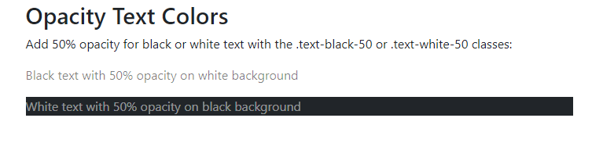

Background Color
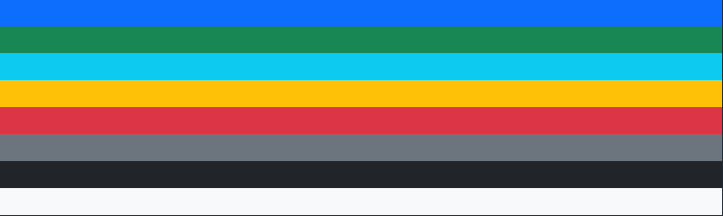
The classes for background colors are : .bg-primary, .bg-success, .bg-info, .bg-warning, .bg-danger, .bg-secondary, .bg-dark and .bg-light .
The .bg-color classes above does not work well with text, or atleast then you have to specify a proper .text-color class to get the right text color for each background.
<div class="container mt-3">
<h2>Background Color with Contrasting Text Color</h2>
<p class="text-bg-primary">This text is important.</p>
<p class="text-bg-success">This text indicates success.</p>
<p class="text-bg-info">This text represents some information.</p>
<p class="text-bg-warning">This text represents a warning.</p>
<p class="text-bg-danger">This text represents danger.</p>
<p class="text-bg-secondary">Secondary background color.</p>
<p class="text-bg-dark">Dark grey background color.</p>
<p class="text-bg-light">Light grey background color.</p>
</div>

However, you can use .text-bg-color classes and bootstrap will automatically handle the appropriate text color for each background color :
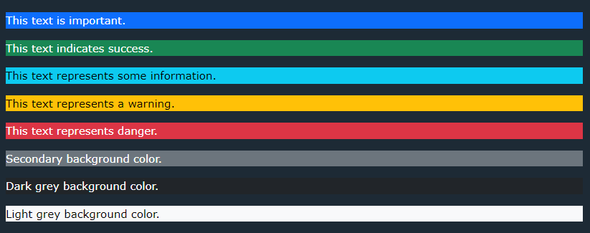

BS5 Tables

Basic Table
A basic Bootstrap 5 table has light padding and horizonatal dividers.
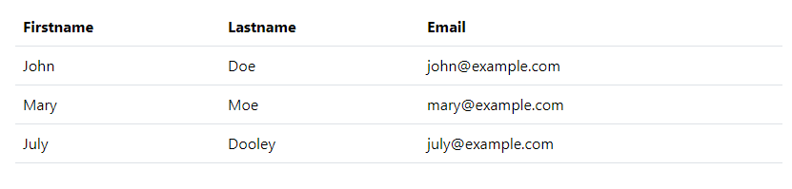
The .table class adds basic syling to a table :
Code :
<div class="container mt-3">
<h2>Basic Table</h2>
<p>
The .table class add basic styling (light padding and horizontanl
dividers) to a table :
</p>
<table class="table">
<thead>
<tr>
<th>Firstname</th>
<th>lastname</th>
<th>Email</th>
</tr>
</thead>
<tbody>
<tr>
<td>John</td>
<td>Doe</td>
<td>john@example.com</td>
</tr>
<tr>
<td>Anna</td>
<td>Smith</td>
<td>Anna@example.com</td>
</tr>
<tr>
<td>July</td>
<td>Dooley</td>
<td>july@example.com</td>
</tr>
</tbody>
</table>
</div>

Striped Rows :
The .table-striped class adds zebra-stripes to table :
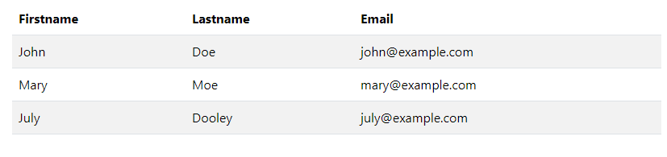

Bordered Table :
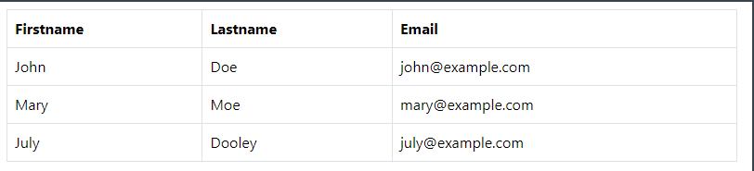
The .table-bordered class adds borders on all sides of the table and cells :

Hover Rows
The .table-hover class adds a hover effect (grey background) on table rows : 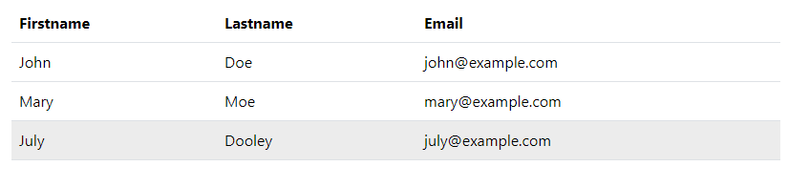

Black/Dark Table
The .table-dark class adds a black background to the table :

Dark Striped Table
Combine .table-dark and .table-stripped to create a dark, striped table

Borderless Table
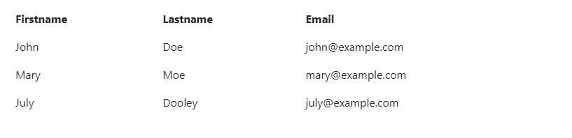
The .table.borderless class removes borders from the table: D

Contextual Class
Contextual classes can be used to color the whole table (<table>), the table row (<tr>) or teble cells (<td>) .
<div class="container mt-3">
<h2>Contextual Classes</h2>
<p>
Contextual classes can be used to color the table, table rows or table
cells. The classes that can be used are: .table-primary, .table-success,
.table-info, .table-warning, .table-danger, .table-active,
.table-secondary, .table-light and .table-dark:
</p>
<table class="table">
<thead>
<tr>
<th>Firstname</th>
<th>Lastname</th>
<th>Email</th>
</tr>
</thead>
<tbody>
<tr>
<td>Default</td>
<td>Defaultson</td>
<td>def@somemail.com</td>
</tr>
<tr class="table-primary">
<td>Primary</td>
<td>Joe</td>
<td>joe@example.com</td>
</tr>
<tr class="table-success">
<td>Success</td>
<td>Doe</td>
<td>john@example.com</td>
</tr>
<tr class="table-danger">
<td>Danger</td>
<td>Moe</td>
<td>mary@example.com</td>
</tr>
<tr class="table-info">
<td>Info</td>
<td>Dooley</td>
<td>july@example.com</td>
</tr>
<tr class="table-warning">
<td>Warning</td>
<td>Refs</td>
<td>bo@example.com</td>
</tr>
<tr class="table-active">
<td>Active</td>
<td>Activeson</td>
<td>act@example.com</td>
</tr>
<tr class="table-secondary">
<td>Secondary</td>
<td>Secondson</td>
<td>sec@example.com</td>
</tr>
<tr class="table-light">
<td>Light</td>
<td>Angie</td>
<td>angie@example.com</td>
</tr>
<tr class="table-dark">
<td>Dark</td>
<td>Bo</td>
<td>bo@example.com</td>
</tr>
</tbody>
</table>
</div>
The contextual classes that can be used are:
Class | Description
.table-primary | Blue: Indicates an important action
.table-success | Green: Indicates a successful or positive action
.table-danger | Red: Indicates a dangerous or potentially negative action
.table-info | Light blue: Indicates a neutral informative change or action
.table-warning | Orange: Indicates a warning that might need attention
.table-active | Grey: Applies the hover color to the table row or table cell
.table-secondary | Grey: Indicates a slightly less important action
.table-light | Light grey table or table row background
.table-dark | Dark grey table or table row background

Responsive Tables
The .table-responsive class adds a scrollbar to the table when needed (when it is too big horizontally) :
You can also decide when the table should get a scrollbar, depending on the screen width :
.table-responsive-sm
.table-responsive-lg
.table-responsive-xl
.table-responsive-xxl

BS5 Images

Image Shapes
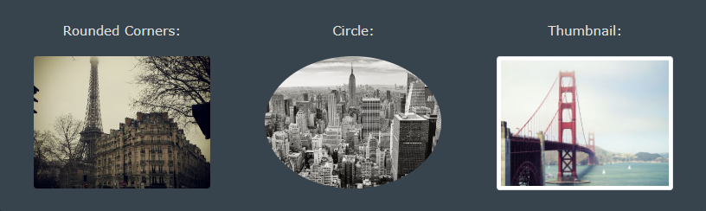

Rounded Corners
The .rounded class adds rounded corners to an image

Cirlcle
The .rounded-circle class shapes the image to cirlce

Thumbnail
The .img-thumbnail class shapes the image to a thumbnail (bordered):

Aligning images
Float an image to the left with the .float-start class or the right with .float-end :

Centered Image
Center an image by addding the utility classes .mx-auto (margin: auto) and .d-block (display:block) to the image:
Responsive Images
Images come in all sizes. so do screens. Responsive images automatically djust to fit the size of the screen.
Create reponsive images by adding an .img-fluid class to <img> tag. The image will then sclae nicely to the parent element.
The .img-fluid class applies max-width: 100%; and height:auto; to the image :

BS5 Jumbotron
A jumbotron was introduced in BS3 as a big padded box for calling extra attention to some special content or information.
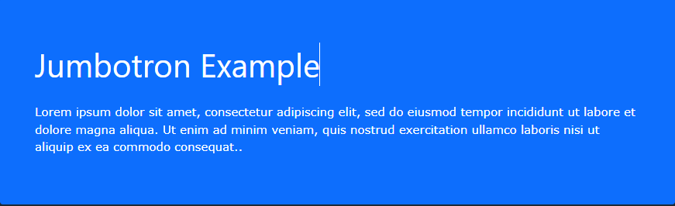
Jumbotrons are no longer supported in BS5. However, you can use a <div> element and add special hleper classes together with a color class to achieve the same effect :

BS5 Alerts

Alerts
Bootstrap 5 provides an easy way to create predefined alert messages :
Alerts are created with The .alert class, followed by one of the contextual classes .alert-success, .alert-info, .alert-warning, .alert-danger, .alert-primary, .alert-secondary, .alert-light or .alert-dark
Code :
<div class="container mt-3">
<h2>Alerts</h2>
<p>
Alerts are created with the .alert class, followed by a contextual color
classes:
</p>
<div class="alert alert-success">
<strong>Success!</strong> This alert box could indicate a successful or
positive action.
</div>
<div class="alert alert-info">
<strong>Info!</strong> This alert box could indicate a neutral
informative change or action.
</div>
<div class="alert alert-warning">
<strong>Warning!</strong> This alert box could indicate a warning that
might need attention.
</div>
<div class="alert alert-danger">
<strong>Danger!</strong> This alert box could indicate a dangerous or
potentially negative action.
</div>
<div class="alert alert-primary">
<strong>Primary!</strong> Indicates an important action.
</div>
<div class="alert alert-secondary">
<strong>Secondary!</strong> Indicates a slightly less important action.
</div>
<div class="alert alert-dark">
<strong>Dark!</strong> Dark grey alert.
</div>
<div class="alert alert-light">
<strong>Light!</strong> Light grey alert.
</div>
</div>

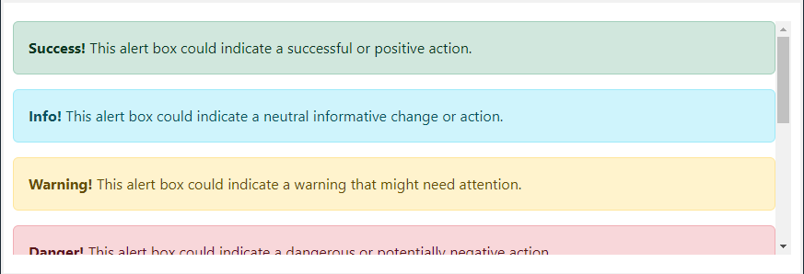

Alert Links
Add .alert-links class to any links inside the alert box to create “matching colored links” :

Closing Alerts
To close the alert message, add a .alert-dimissible class to the alert container, Then add class=”btn-close” and data-bs-dimiss=”alert” to a link or a button element (when you click on this the alert box will disappear)
<div class="alert alert-success alert-dismissible">
<button
type="button"
class="btn-close"
data-bs-dismiss="alert"
></button>
<strong>Success!</strong> This alert box could indicate a successful or
positive action.
</div>

Animated Alerts
The .fade and .show classes adds a fading effect when closing the alert message :

BS5 Buttons

Button Styles
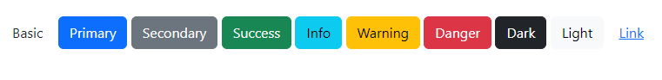
Bootstrap 5 proviedes different syles of buttons:
<div class="container mt-3">
<button type="button" class="btn">Basic</button>
<button type="button" class="btn btn-primary">Primary</button>
<button type="button" class="btn btn-secondary">Secondary</button>
<button type="button" class="btn btn-success">Success</button>
<button type="button" class="btn btn-info">Info</button>
<button type="button" class="btn btn-warning">Warning</button>
<button type="button" class="btn btn-danger">Danger</button>
<button type="button" class="btn btn-dark">Dark</button>
<button type="button" class="btn btn-light">Light</button>
<button type="button" class="btn btn-link">Link</button>
</div>
The button classes can be used on <a>, <button>, or <input> elements :

Button outline
Bootstrap 5 also provides eight outline/bordered buttons.
Move the mouse over them to see an additional “hover” effect:
<div class="container mt-3">
<h2>Button Outline</h2>
<button type="button" class="btn btn-outline-primary">Primary</button>
<button type="button" class="btn btn-outline-secondary">Secondary</button>
<button type="button" class="btn btn-outline-success">Success</button>
<button type="button" class="btn btn-outline-info">Info</button>
<button type="button" class="btn btn-outline-warning">Warning</button>
<button type="button" class="btn btn-outline-danger">Danger</button>
<button type="button" class="btn btn-outline-dark">Dark</button>
<button type="button" class="btn btn-outline-light text-dark">
Light
</button>
</div>

Button sizes
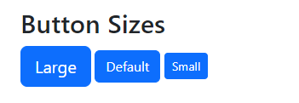
Use the .btn-lg class for large buttons or .btn-sm class for small buttons:
<div class="container mt-3">
<h2>Button Sizes</h2>
<button class="btn btn-primary btn-lg">Large</button>
<button class="btn btn-primary">Default</button>
<button class="btn btn-primary btn-sm">Small</button>
</div>

Block Level Buttons
To Create a block level button that spans the entire width of the parent element, use the .d-grid “helper” class on the parent element :
<div class="container mt-3">
<h2>Block Level Buttons</h2>
<p>
To create a block level button that spans the entire width of the parent
element, use the .d-grid "helper" class on the parent element:
</p>
<div class="d-grid">
<button type="button" class="btn btn-primary btn-block">
Full-Width Button
</button>
</div>
</div>
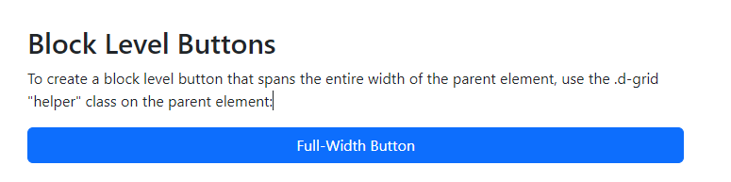
If you have many block-level buttons, you can control the space between them with the .gap-* class:
<div class="d-grid gap-3">
<button type="button" class="btn btn-primary btn-block">
Full-Width Button
</button>
<button type="button" class="btn btn-primary btn-block">
Full-Width Button
</button>
<button type="button" class="btn btn-primary btn-block">
Full-Width Button
</button>
</div>

Acitve/Disabled Buttons
A button can be set to an active (apear pressed) or a disabled (unclickable) state :
The class .active makes a button appear presssed , and the disabled attribute makes a button unclickable. Note that <a> elements do not support the disabled attribute and must therefore use .disabled class to make it visually appear disabled
<button class="btn btn-primary active">Active Primary</button>
<button class="btn btn-primary disabled">disabled Primary</button>

BS 5 Button Groups
Button Groups
Bootstrap 5 allows you to group a series of buttons together (on a single line) in a button group :
Use a <div> element with class .btn-group to create a buttion group : 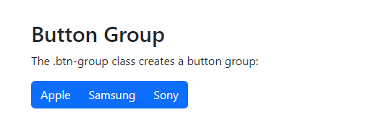
<div class="container mt-3">
<h2>Button Group</h2>
<p>The .btn-group class creates a button group:</p>
<div class="btn-group">
<button type="button" class="btn btn-primary">Apple</button>
<button type="button" class="btn btn-primary">Samsung</button>
<button type="button" class="btn btn-primary">Sony</button>
</div>
</div>
Tip : Instead of applying button sizes to every in a group, use class .btn-group-lg for large button group or the .btn-group-sm for a small group :

Vertical Button Groups
Bootstrap 5 also supports vertical button groups :
Use the class .btn-group-vertical to create a vertical button group

Nesting Button Groups & Dropdown Menus
Nest button groups to create dropdown menus (you will learn more about dropdonws in a later chapter) :
<div class="btn-group">
<button type="button" class="btn btn-primary">Apple</button>
<button type="button" class="btn btn-primary">Samsung</button>
<div class="btn-group">
<button
type="button"
class="btn btn-primary dropdown-toggle"
data-bs-toggle="dropdown"
>
Sony
</button>
<div class="dropdown-menu">
<a class="dropdown-item" href="#">Tablet</a>
<a class="dropdown-item" href="#">Smartphone</a>
</div>
</div>
</div>

Badges
Badges are used to add additional information to any content:
Use .badge class together with a contextual class (like .bg-secondary) within <span> elements to create rectangular badges. Note that badges sclae to match the size of the parent element (if any) :
<div class="container mt-3">
<h2>Badges</h2>
<h1>Example heading <span class="badge bg-secondary">New</span></h1>
<h2>Example heading <span class="badge bg-secondary">New</span></h2>
<h3>Example heading <span class="badge bg-secondary">New</span></h3>
<h4>Example heading <span class="badge bg-secondary">New</span></h4>
<h5>Example heading <span class="badge bg-secondary">New</span></h5>
<h6>Example heading <span class="badge bg-secondary">New</span></h6>
</div>
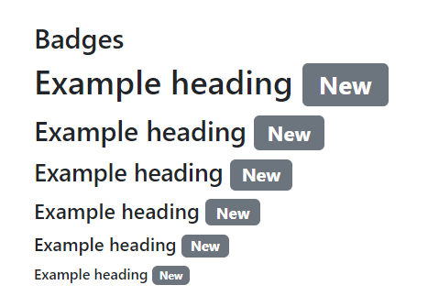

Contextual Bages
Use any of the contextual classes (.bg-*) to change the color of a badge :
<div class="container mt-3">
<h2>Contextual Badges</h2>
<span class="badge bg-primary">Primary</span>
<span class="badge bg-secondary">Secondary</span>
<span class="badge bg-success">Success</span>
<span class="badge bg-danger">Danger</span>
<span class="badge bg-warning">Warning</span>
<span class="badge bg-info">Info</span>
<span class="badge bg-light">Light</span>
<span class="badge bg-dark">Dark</span>
</div>
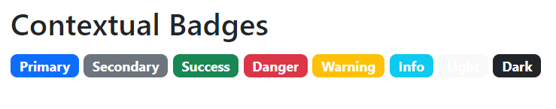

Pill Badges
Use .rounded-pill class to make the badges more round:
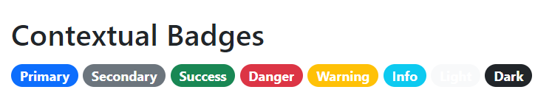

Badges inside an Element
<button type="button" class="btn btn-primary">
Messages <span class="badge bg-danger">4</span>
</button>
BS5 Progress Bars

Basic Progress Bar
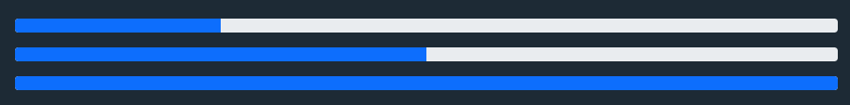
To create a default progress bar, add .progress class to a container element add add the .progress-bar class to its child element. Use the CSS width property to set the width of the progress bar :
<div class="progress">
<div class="progress-bar" style="width: 70%"></div>
</div>

Progress bar Height
The height of the progress bar is 1rem (usually 16px) by default. Use the CSS height property to change it :
<div class="progress" style="height: 10px">
<div class="progress-bar" style="width: 70%"></div>
</div>

Progress Bar Lebels
<div class="progress">
<div class="progress-bar" style="width: 70%">70%</div>
</div>

Colored progrees bar
By Default, the progress bar is blue (primary), use any of the contextual background class to change its color .

Striped Progress Bars
Use .progress-bar-stripped class to add stripes to the progresss bar :

Animated Progress Bar
Add the .progress-bar-animated class to animate the progress bar :

Multiple Progress Bars
Progress bars can also be stacked
<div class="progress">
<div class="progress-bar bg-success" style="width: 40%">Free Space</div>
<div class="progress-bar bg-warning" style="width: 10%">Warning</div>
<div class="progress-bar bg-danger" style="width: 20%">Danger</div>
</div>

Spinners
To Create a spinner/loader, use the .spinner-border class:
<div class="spinner-border"></div>
Colored Spinners
Use any text color utilites to add a color to the spinner :
<div class="spinner-border text-muted"></div>
<div class="spinner-border text-primary"></div>
<div class="spinner-border text-success"></div>
<div class="spinner-border text-info"></div>
<div class="spinner-border text-warning"></div>
<div class="spinner-border text-danger"></div>
<div class="spinner-border text-secondary"></div>
<div class="spinner-border text-dark"></div>
<div class="spinner-border text-light"></div>

Growing Spinners
Use the .spiner-grow class if you want the spinner/loader to grow instead of “spin” :
<div class="spinner-grow text-muted"></div>
<div class="spinner-grow text-primary"></div>
<div class="spinner-grow text-success"></div>
<div class="spinner-grow text-info"></div>
<div class="spinner-grow text-warning"></div>
<div class="spinner-grow text-danger"></div>
<div class="spinner-grow text-secondary"></div>
<div class="spinner-grow text-dark"></div>
<div class="spinner-grow text-light"></div>
Spinner Size
Use .spinner-border-sm or .spinner-grow-sm
Spiner Buttons
You can also add spinners to a button, with or witout text :
<button class="btn btn-primary">
<span class="spinner-border spinner-border-sm"></span>
</button>

<button class="btn btn-primary">
<span class="spinner-border spinner-border-sm"></span>
Loading..
</button>

<button class="btn btn-primary" disabled>
<span class="spinner-border spinner-border-sm"></span>
Loading..
</button>

<button class="btn btn-primary" disabled>
<span class="spinner-grow spinner-grow-sm"></span>
Loading..
</button>

Bootstrap 5 Pagination
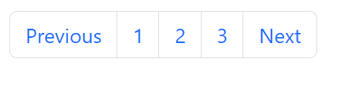If you hava a web sie with lots of pages, you may wish add some sort of pagination to each page .
To create a basic pagination, add .pagination class to an <ul> element. Then add the page-item to each <li> element and a .page-link class to each link inside <li> .
<ul class="pagination">
<li class="page-item"><a href="#" class="page-link">Previous</a></li>
<li class="page-item"><a href="#" class="page-link">1</a></li>
<li class="page-item"><a href="#" class="page-link">2</a></li>
<li class="page-item"><a href="#" class="page-link">3</a></li>
<li class="page-item"><a href="#" class="page-link">Next</a></li>
</ul>

Active State
The .actie class is used to “highlight” the current page:
<ul class="pagination">
<li class="page-item"><a class="page-link" href="#">Previous</a></li>
<li class="page-item"><a class="page-link" href="#">1</a></li>
<li class="page-item active"><a class="page-link" href="#">2</a></li>
<li class="page-item"><a class="page-link" href="#">3</a></li>
<li class="page-item"><a class="page-link" href="#">Next</a></li>
</ul>

Disabled State
The .diabled Class is used for un-clickable links :

Pagination Sizing
Pagination blocks can also be sized to a larger or a smaller size :
Add class .pagination-lg for larger blocks or .pagination-sm for smaller blocks :

Pagination Alignment
Use utility classes to change the alignement of the pagination . (after)
Breadcrumbs
Another form for pagination, is breadcrumbs :
The .breadcrumbs and .breadcrumb-item classes indicates the current pages’s location withing a navigational hierachy :
<div class="container mt-3">
<h2>Breadcrumbs</h2>
<p>
The .breadcrumb class indicates the current page's location within a
navigational hierarchy:
</p>
<ul class="breadcrumb">
<li class="breadcrumb-item"><a href="#">Photos</a></li>
<li class="breadcrumb-item"><a href="#">Summer 2017</a></li>
<li class="breadcrumb-item"><a href="#">Italy</a></li>
<li class="breadcrumb-item active">Rome</li>
</ul>
</div>
Img :
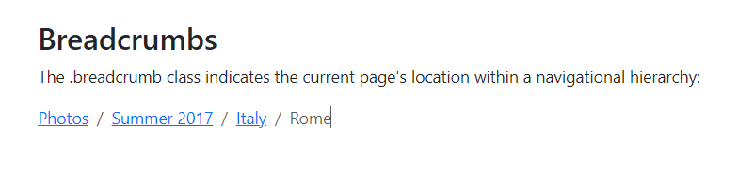

Bootstrap 5 List Groups

Basic List Groups
The most basic list group is an unordered list with list items:
To create a basic list group, use an <ul> element with class .list-group, and <li> elements with class .list-group-item :
<div class="container mt-3">
<h2>Basic List Group</h2>
<ul class="list-group">
<li class="list-group-item">First item</li>
<li class="list-group-item">Second item</li>
<li class="list-group-item">Third item</li>
</ul>
</div>
Active State
Use the .active class to highlight the current item .
List Group With linked items
To create a list group with linked items, use <div> instead of <ul> and <a> instead of <li>, optionally, add the .list-group-item-action class if you want a grey background color on hover :
Disabled Item
The .disabled class adds a lighte text color to the disabled item. And When used on links, it will remove the hover effect :
Numbered list Groups
Use the .list-group-numbered class to create list items with numbers in fron of them :
Horizontal list groups
If you want the list items to dipaly horizontally instead of veritcally (side by side instead of on top of each other), add the .list-group-horizontal class to .list-group :
Contextual Classes
Contextula classes can be used ot add color to the list item :
List group with badges
Combine .badge classes with utility/helper classes to add badges inside the list group :
<div class="container mt-3">
<h2>List Group With Badges</h2>
<p>
Combine .badge classes with utility/helper classes to add badges inside
the list group:
</p>
<ul class="list-group">
<li
class="list-group-item d-flex justify-content-between align-items-center"
>
Inbox
<span class="badge bg-primary rounded-pill">12</span>
</li>
<li
class="list-group-item d-flex justify-content-between align-items-center"
>
Ads
<span class="badge bg-primary rounded-pill">50</span>
</li>
<li
class="list-group-item d-flex justify-content-between align-items-center"
>
Junk
<span class="badge bg-primary rounded-pill">99</span>
</li>
</ul>
</div>
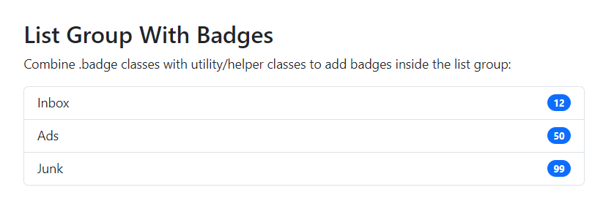

Boostrap 5 Card
Cards
A card in Boostrap 5 is a bordered box with some padding around its content. It includes options for headers, footers, colors, etc.


Basic Card
A basic card is created ith the .card class, and content inside the card has .card-body class .

Header aBasic Card
A basic card is created ith the .card class, and content inside the card has .card-body class .
Header and footer
c

Tiltles, text, and links
nd footer
The .card-header class adds a heading to the card and the .card-footer class adds a footer to the card

Contextual Cards
To add a background color to th card, use contextual classes

Tiltles, text, and links
Use .card-title to ad titles to any heading element. The .card-text class is used to remove bottom mrging for a <p> element if it is the last child (or the only one) inside .cqrd-body . The .card-link class adds a blue color to any link, and hover effect
<div class="card">
<div class="card-body">
<h4 class="card-title">Card title</h4>
<p class="card-text">Some example text. Some example text.</p>
<a href="#" class="card-link">Card link</a>
<a href="#" class="card-link">Another link</a>
</div>
</div>

Card Images
Add .card-img-top or .card-img-bottom to an <img> to place the image at the top or at the bottom inside the card .
Note that we have added the image outside of the .card-body to span the entire width :
div class="container mt-3">
<h2>Card Image</h2>
<p>Image at the top (card-img-top):</p>
<div class="card" style="width:400px">
<img class="card-img-top" src="img/360_F_196039475_6MbF6oSsJJIQdSkS5sBUl52JfvYVSeNP.jpg" alt="Card image" style="width:100%">
<div class="card-body">
<h4 class="card-title">John Doe</h4>
<p class="card-text">Some example text some example text. John Doe is an architect and engineer</p>
<a href="#" class="btn btn-primary">See Profile</a>
</div>
</div>
<br>

<p>Image at the bottom (card-img-bottom):</p>
<div class="card" style="width:400px">
<div class="card-body">
<h4 class="card-title">Jane Doe</h4>
<p class="card-text">Some example text some example text. Jane Doe is an architect and engineer</p>
<a href="#" class="btn btn-primary">See Profile</a>
</div>
<img class="card-img-bottom" src="img/360_F_196039475_6MbF6oSsJJIQdSkS5sBUl52JfvYVSeNP.jpg" alt="Card image" style="width:100%">
</div>
</div>
Card imae overlays
Turn an image into a card background and use .car-img-overlay to add text on top of the image .
Baic Dropdown A dropdown menu is toggelable menu that allows the user to choose one value from a predefined list :
<div class="dropdown">
<button
type="button"
class="btn btn-primary dropdown-toggle"
data-bs-toggle="dropdown"
>
Dropdown button
</button>
<ul class="dropdown-menu">
<li><a class="dropdown-item" href="#">Link 1</a></li>
<li><a class="dropdown-item" href="#">Link 2</a></li>
<li><a class="dropdown-item" href="#">Link 3</a></li>
</ul>
</div>
Explained
The .dropdown class indicates a dropdown menu.
To open the dropdown menu, use a button or a link with a class of .dropdown-toggle and the data-bs-toggle=”dropdown” attribute.
Add the .dropdonn-menu class to a container element, like <iv> or <ul< , to actually build the dropdown menu.
Then add the dropdown-item class to each element (links or buttons) inside the dropdown menu.
Dropdown divider
The .dropdown-divider class is used to separate links the dropdown menu with a thin horizontal border :
<li><hr class="dropdown-divider"></hr></li>

Dropdown Header
The .drop-down class is used to add headers inside the dropdonwn menu :
Disable and Active items
Highlight a specific dropdown item with the .active class (adds a blue background color )
To disable and Active items
Highlight a specific dropdown item with .active class (adds a blue Background color )
To disable an item in the dropdown menu, use the .disabled class (gets a light-grey text color ad a “no-parking-sign” icon on hover)
Dropdown Position
You can also create “dropend” or “dropstart” menu, by adding the .dropend or .drpstart class to the dropdown element . note that the caret/arrow is added automatically
Dropdown Menu Right
To right-align the dropdown menu, add the .dropdown-menu-end class to the element with .dropdown-menu :
dropUp
if you want the dropdown menu to expand upwards instead of donwwards, change the <div>

Collapse
Basic Collapsible
Collapsibles are useful when you want to hide and show large amount of content :
Explain :
The .collapse class indicates a collapsible element ( a <div> in our example ) this is the content that will be shown or hidden with a click of a button
To control (show/hide) the collapsile content, add the data-bs-toggle=”collapse” attribute to an <a> or <button> element. Then add the data-bs-target=”#id” attribute to connect the button with the collapsile conten (<div id =”demo”>
Note : for <a> elements, you can use the href attrbute instead of the data-bs-target attribute:
<div class="container mt-3">
<h2>Simple Collapsible</h2>
<p>Click on the button to toggle between showing and hiding content.</p>
<button
type="button"
class="btn btn-primary"
data-bs-toggle="collapse"
data-bs-target="#demo"
>
Simple collapsible
</button>
<div id="demo" class="collapse">
Lorem ipsum dolor sit amet, consectetur adipisicing elit, sed do eiusmod
tempor incididunt ut labore et dolore magna aliqua. Ut enim ad minim
veniam, quis nostrud exercitation ullamco laboris nisi ut aliquip ex ea
commodo consequat.
</div>
</div>

Accordion
The following example shows a simple accordion by extending the card componenet.
Note : use the data-bs-parent attribute to make sure that all collapsible elments under the specified parent will be closed when one of the collapsible item is shown.
<div class="container mt-3">
<h2>Accordion Example</h2>
<p>
<strong>Note:</strong> The <strong>data-bs-parent</strong> attribute
makes sure that all collapsible elements under the specified parent will
be closed when one of the collapsible item is shown.
</p>
<div id="accordion">
<div class="card">
<div class="card-header">
<a class="btn" data-bs-toggle="collapse" href="#collapseOne">
Collapsible Group Item #1
</a>
</div>
<div
id="collapseOne"
class="collapse show"
data-bs-parent="#accordion"
>
<div class="card-body">
Lorem ipsum dolor sit amet, consectetur adipisicing elit, sed do
eiusmod tempor incididunt ut labore et dolore magna aliqua. Ut
enim ad minim veniam, quis nostrud exercitation ullamco laboris
nisi ut aliquip ex ea commodo consequat.
</div>
</div>
</div>
<div class="card">
<div class="card-header">
<a
class="collapsed btn"
data-bs-toggle="collapse"
href="#collapseTwo"
>
Collapsible Group Item #2
</a>
</div>
<div id="collapseTwo" class="collapse" data-bs-parent="#accordion">
<div class="card-body">
Lorem ipsum dolor sit amet, consectetur adipisicing elit, sed do
eiusmod tempor incididunt ut labore et dolore magna aliqua. Ut
enim ad minim veniam, quis nostrud exercitation ullamco laboris
nisi ut aliquip ex ea commodo consequat.
</div>
</div>
</div>
<div class="card">
<div class="card-header">
<a
class="collapsed btn"
data-bs-toggle="collapse"
href="#collapseThree"
>
Collapsible Group Item #3
</a>
</div>
<div id="collapseThree" class="collapse" data-bs-parent="#accordion">
<div class="card-body">
Lorem ipsum dolor sit amet, consectetur adipisicing elit, sed do
eiusmod tempor incididunt ut labore et dolore magna aliqua. Ut
enim ad minim veniam, quis nostrud exercitation ullamco laboris
nisi ut aliquip ex ea commodo consequat.
</div>
</div>
</div>
</div>
</div>

Boostrap 5 Navs

Nav Menus
If you want to create a simple horizontal menu, add the .nav class to <ul> element, followed by .nav-item for each <li> and add the .nav-link class to their links :

Aligned Nav
Add the .justify-content-center class to center the nav, and the .justify-content-end class to right-align the nav.

Tabs
Turn the nav menu into navigation tabs with the .nav-tabs class.Add the .active class to the active/current link. If you want the tabs to be togglable, see the last example on this page.

Pills
Turn the nav menu into navigation pills with the .nav-pills class. If you want the pills to be togglable, see the last example on this page.

Justified Tabs/pills
Justify the tabs/pills with the .nav-justified class (equal width) :
<div class="container mt-3">
<h2>Justified Tabs/Pills</h2>
<p>To justify tabs/pills (equal width), use the .nav-justified class:</p>
<ul class="nav nav-pills nav-justified">
<li class="nav-item">
<a class="nav-link active" href="#">Active</a>
</li>
<li class="nav-item">
<a class="nav-link" href="#">Link</a>
</li>
<li class="nav-item">
<a class="nav-link" href="#">Link</a>
</li>
<li class="nav-item">
<a class="nav-link disabled" href="#">Disabled</a>
</li>
</ul>
<br />

<p>Justified tabs:</p>
<ul class="nav nav-tabs nav-justified">
<li class="nav-item">
<a class="nav-link active" href="#">Active</a>
</li>
<li class="nav-item">
<a class="nav-link" href="#">Link</a>
</li>
<li class="nav-item">
<a class="nav-link" href="#">Link</a>
</li>
<li class="nav-item">
<a class="nav-link disabled" href="#">Disabled</a>
</li>
</ul>
</div>

Pills with Dropdown
<ul class="nav nav-pills">
<li class="nav-item">
<a href="#" class="nav-link active">Active</a>
</li>
<!-- start -->
<li class="nav-item dropdown">
<a href="#" class="nav-link dropdown-toggle" data-bs-toggle="dropdown"
>dropdown</a
>
<ul class="dropdown-menu">
<li><a href="#" class="dropdown-item">link #1</a></li>
<li><a href="#" class="dropdown-item">link #2</a></li>
<li><a href="#" class="dropdown-item">link #3</a></li>
</ul>
</li>
<li class="nav-item">
<a class="nav-link" href="#">Link</a>
</li>
<li class="nav-item">
<a class="nav-link disabled" href="#">Disabled</a>
</li>
</ul>
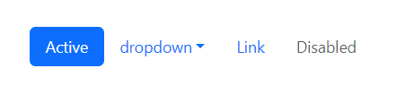
Toggleable / Dynamic Tabs
To make the tabs toggleable, add the data-toggle=”tab” attribute to each link. Then add a .tab-pane class with a unique ID for every tab and wrap them inside a <div> element with class .tab-content.
If you want the tabs to fade in and out when clicking on them, add the .fade class to .tab-pane :
<!-- Nav tabs -->
<ul class="nav nav-tabs">
<li class="nav-item">
<a href="#home" class="nav-link active" data-bs-toggle="tab">Home</a>
</li>
<li class="nav-item">
<a href="#menu1" class="nav-link" data-bs-toggle="tab">Menu 1</a>
</li>
<li class="nav-item">
<a href="#menu2" class="nav-link" data-bs-toggle="tab">Menu 2</a>
</li>
</ul>
<!-- Tab panes -->
<div class="tab-content">
<div class="tab-pane container active" id="home">
Lorem ipsum, dolor sit amet consectetur adipisicing elit. Non animi
tenetur, asperiores excepturi reiciendis quas mollitia quae fugiat,
</div>
<div class="tab-pane container fade" id="menu1">
Ut enim ad minim veniam, quis nostrud exercitation ullamco laboris nisi
ut aliquip ex ea commodo consequat.
</div>
<div class="tab-pane container fade" id="menu2">
Sed ut perspiciatis unde omnis iste natus error sit voluptatem
accusantium doloremque laudantium, totam rem aperiam.
</div>
</div>
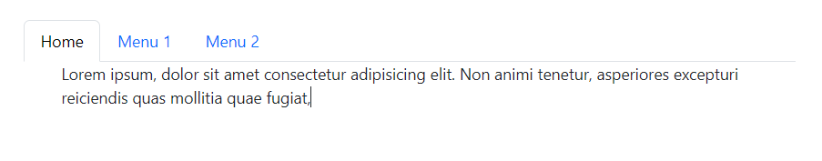

Toggleable / Dynamic Pills
The same code applies to pills; only change the data-toggle attribute to data-toggle=”pill”

Bootstrap 5 Navbars

Navigation Bars
A navigation bar is a navigation header that is placed at the top of the page :

Basic Navbar
With Bootstrap, a navigation bar can extend or collapse, depending on the screen size.
A standard navigation bar can extend with the .navbar class, followed by a responsive collapsing class: .navbar-expand-xxl|xl|lg|md|sm (stack the navbar vertically on xxlarge, extra large, medium or small screen)
To Add links inside the navbar, use either an <ul> element (or <div>) with class=”navbar-nav”. Then add <li> elements with a .nav-item followed by an <a> elemnt with a .nav-link class :
<nav class="navbar navbar-expand-sm bg-light">
<div class="container-fluid">
<ul class="navbar-nav">
<li class="nav-item">
<a class="nav-link" href="#">Link 1</a>
</li>
<li class="nav-item">
<a class="nav-link" href="#">Link 2</a>
</li>
<li class="nav-item">
<a class="nav-link" href="#">Link 3</a>
</li>
</ul>
</div>
</nav>

<div class="container-fluid mt-3">
<h3>Basic Navbar Example</h3>
<p>
A navigation bar is a navigation header that is placed at the top of the
page.
</p>
<p>
The navbar-expand-xxl|xl|lg|md|sm class determines when the navbar
should stack vertically (on xxlarge, extra large, large, medium or small
screens).
</p>
</div>

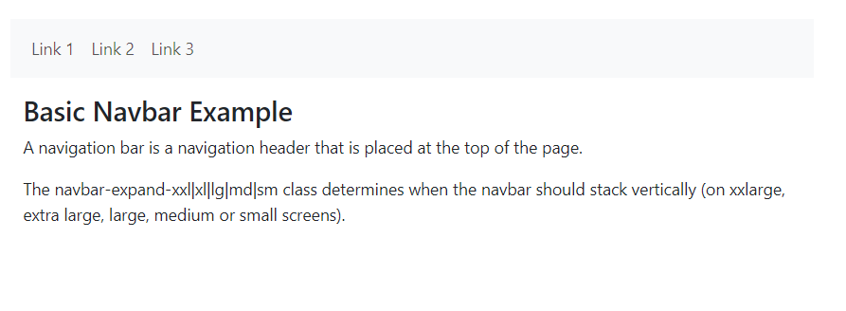

Centered Navbar
Add the .justify-content-center class to center the navigation bar :

Colored Navbar
Use any of the .bg-color classes to change the background color of the navbar (.bg-primary, .bg-success, .bg-info, .bg-warning, .bg-danger, .bg-secondary, .bg-dark and .bg-light)
Tip: Add a white text color to all links in the navbar with the .navbar-dark class, or use the .navbar-light class to add a black text color.
Active/disabled state: Add the .active class to an <a> element to highlight the current link, or the .disabled class to indicate that the link is un-clickable.

Brand / logo
The .navbar-brand class is used to highlight the brand/logo/project name of your page :

Logo
When using the .navbar-brand class with images, bootstrap 5 will automatically style the image to fit the navbar

Navbar Text & example
Use the .navbar-text class to vertical align any elements inside the navbar that are not links ( ensures padding and text color )
Very often , especially on small screen, you want to hide the navigation links and replace them with a button that should reveal then clicked on .
To create a collapsible navigaton bar, use a button with class=”navbar-toggler”, data-bs-toggle=”collapse” and data-bs-target=”#thetarget”. Then wrap the navbar content ( links, etc) inside a <div> element with class=”collapse navbar-collapse”, folowed by an id that matches the data-bs-target of the button : “thetarget” .
Tip : you can also remove the .na
<nav class="navbar navbar-expand-sm bg-light">
<div class="container-fluid">
<ul class="navbar-nav">
<li class="nav-item">
<a class="nav-link" href="#">Link 1</a>
</li>
<li class="nav-item">
<a class="nav-link" href="#">Link 2</a>
</li>
<li class="nav-item">
<a class="nav-link" href="#">Link 3</a>
</li>
</ul>
</div>
</nav>

Img :
Tip : you can also remove the .navbar-expand-md class to ALWAYS hide navbar links and display the toggler button .

Fixed Navigation Bar
The naviaon bar can also be fixed at the top or at the bottom of the page . A fixed navigatoin ar stay s vistile in a fixed position (top or bottom) independent of the page scroll .
The .fixed-top class makes the navigation bar fixed at the top :
<nav class="navbar navbar-expand-sm bg-dark navbar-dark fixed-top">
<div class="container-fluid">
<a href="#" class="navbar-brand">fixed top</a>
</div>
</nav>
<div class="container-fluid" style="margin-top: 80px">
<h3>Top Fixed Navbar</h3>
<p>
A fixed navigation bar stays visible in a fixed position (top or bottom)
independent of the page scroll.
</p>
<h1>Scroll this page to see the effect</h1>
</div>
.fixed-bottom class to make the navbar stay at the bottom of the page .
Use The .sticky-top class to make the navbar fixed/stay at the top of the page you scroll past it. Note : this class does not work in IE11 and earlier (will treat it as position relative )

Boostrap 5 Carousel

Carousel / slideshow
The Carousel is slideshow for cycling through elements :

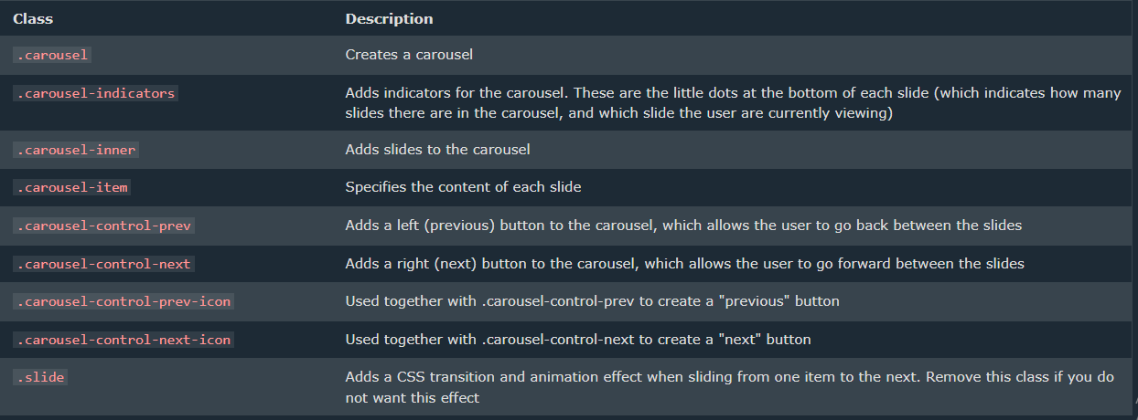
Modal

Modals
The Modal componenet is a dialog box/popup window that is displayed on top of the current page .

Hox to Create a Modal
The following example show how to create a basic modal :
<div class="container mt-3">
<h3>Modal Example</h3>
<p>Click on the button to open the modal.</p>

<button
type="button"
class="btn btn-primary"
data-bs-toggle="modal"
data-bs-target="#myModal"
>
Open modal
</button>
</div>

<!-- The Modal -->
<div class="modal" id="myModal">
<div class="modal-dialog">
<div class="modal-content">
<!-- Modal Header -->
<div class="modal-header">
<h4 class="modal-title">Modal Heading</h4>
<button
type="button"
class="btn-close"
data-bs-dismiss="modal"
></button>
</div>

<!-- Modal body -->
<div class="modal-body">Modal body..</div>

<!-- Modal footer -->
<div class="modal-footer">
<button
type="button"
class="btn btn-danger"
data-bs-dismiss="modal"
>
Close
</button>
</div>
</div>
</div>
</div>
Add animation
Use the .fade class to add a fading effect when opening and closing the modal :
<!-- Fading modal -->
<div class="modal fade"></div>

<!-- Modal without animation -->
<div class="modal"></div>

Bootstrap 5 Popover

Popovers
The popover component is smilar to tooltips; it is a pop-up box that appears when the user clicks on a element.
The difference is that the popover can contain much more content.
How to Create A Popover
To create a popover, add the data-bs-toggle=”popover” attribute to an element.
Use the title attribute to specify the header text of the popover, and use the data-bs-content attribute to specify the text that should be displayed inside the popover’s body :
Note : popovers must be initialized with js to work .
The following code will enable all popovers in the document :
<div class="container mt-3">
<h3>Popover Example</h3>

<button
type="button"
class="btn btn-primary"
data-bs-toggle="popover"
title="Popover Header"
data-bs-content="Some content inside the popover"
>
Toggle popover
</button>
</div>

<script>
var popoverTriggerList = [].slice.call(
document.querySelectorAll('[data-bs-toggle="popover"]')
);
var popoverList = popoverTriggerList.map(function (popoverTriggerEl) {
return new bootstrap.Popover(popoverTriggerEl);
});
</script>
Positioning Popovers
By default, the popover will appear on the right side of the element.
Use the data-bs-placement attribute to set the position of the popover on top, bottom, left, or the right side of the element :
<div class="container mt-5">
<h3>Popover Positioning</h3>
<p>Click on the links to see the popover in action:</p>
<a
href="#"
title="Header"
data-bs-toggle="popover"
data-bs-placement="top"
data-bs-content="Content"
>Top</a
>
<a
href="#"
title="Header"
data-bs-toggle="popover"
data-bs-placement="bottom"
data-bs-content="Content"
>Bottom</a
>
<a
href="#"
title="Header"
data-bs-toggle="popover"
data-bs-placement="left"
data-bs-content="Content"
>Left</a
>
<a
href="#"
title="Header"
data-bs-toggle="popover"
data-bs-placement="right"
data-bs-content="Content"
>Right</a
>
</div>

<script src="node_modules/bootstrap/dist/js/bootstrap.bundle.js"></script>
<script>
var popoverTriggerList = [].slice.call(
document.querySelectorAll('[data-bs-toggle="popover"]')
);
var popoverList = popoverTriggerList.map(function (popoverTriggerEl) {
return new bootstrap.Popover(popoverTriggerEl, {
trigger: "click",
});
});
</script>

Closing Popovers
By default, the popover is closed when you click on the element again. However, you can use the data-bs-trigger=”focus” attribute which will close the popover when clicking outside the element :
<div class="container mt-3">
<h3>Dismissible Popover</h3>
<a
href="#"
title="dimissible Popover"
data-bs-toggle="popover"
data-bs-trigger="focus"
data-bs-content="Click anywhere in the document to close this popover"
>click me</a
>
</div>
<script src="node_modules/bootstrap/dist/js/bootstrap.bundle.js"></script>
<script>
var popoverTriggerList = [].slice.call(
document.querySelectorAll('[data-bs-toggle="popover"]')
);
var popoverList = popoverTriggerList.map(function (popoverTriggerEl) {
return new bootstrap.Popover(popoverTriggerEl);
});
</script>

Hoverable Popover
Tip : if you want the popover to be displayed when you move the mouse pointer over the element, use the data-bs-trigger attribute with a value of “hover” :
<div class="container mt-3">
<h3>Hoverable Popover</h3>

<a
href="#"
title="Header"
data-bs-toggle="popover"
data-bs-trigger="hover"
data-bs-content="Popover text"
>Hover over me</a
>
</div>

<script src="node_modules/bootstrap/dist/js/bootstrap.bundle.js"></script>
<script>
var popoverTriggerList = [].slice.call(
document.querySelectorAll('[data-bs-toggle="popover"]')
);
var popoverList = popoverTriggerList.map(function (popoverTriggerEl) {
return new bootstrap.Popover(popoverTriggerEl);
});
</script>

Bootstrap 5 Toasts
Toasts
The toast component is like an alert box that is only shown for a couple of seconds when something happens ( when the user clicks on a button, submits a form, etc)
How to Create a Toast
To create a toast, use the .toast class, and add a .toast-header and .toast-body inside of it.
Note : Toasts are hidden by default. Use the .show class if yo want to display it . To close it, use a <button> element and add data-bs-dismiss=”toast” :
Open a Toast
To show a toast with a click of a button, you must initialize it with js: select the specified element and call the toast() method.
The following code will show all “toasts” in the document when you click on button :
<div class="container mt-3">
<h3>Toast Example</h3>
<p>In this example, we use a button to show the toast message.</p>

<button type="button" class="btn btn-primary" id="toastbtn">
Show Toast
</button>

<div class="toast">
<div class="toast-header">
<strong class="me-auto">Toast Header</strong>
<button
type="button"
class="btn-close"
data-bs-dismiss="toast"
></button>
</div>
<div class="toast-body">
<p>Some text inside the toast body</p>
</div>
</div>
</div>
<script src="node_modules/bootstrap/dist/js/bootstrap.bundle.js"></script>
<script>
document.getElementById("toastbtn").onclick = function () {
var toastElList = [].slice.call(document.querySelectorAll(".toast"));
var toastList = toastElList.map(function (toastEl) {
return new bootstrap.Toast(toastEl);
});
toastList.forEach((toast) => toast.show());
};
</script>

Bootstrap 5 Scrollspy

Scrollspy
Scrollspy is used to automatically update links in a navigation list based on scroll position.
Bootstrap 5 offcanvvas
Offcanvas
Offcanvas is similar to modals (hidden by default and shown when activated), except that Is often used as a sidebar navigation menu.
How To create an offcanfas sidebar
The following example shows to create an offcavas sidebar :
<!-- Offcanvas Sidebar -->
<div class="offcanvas offcanvas-start" id="demo">
<div class="offcanvas-header">
<h1 class="offcanvas-title">Heading</h1>
<button
type="button"
class="btn-close text-reset"
data-bs-dismiss="offcanvas"
></button>
</div>
<div class="offcanvas-body">
<p>Some text lorem ipsum.</p>
<p>Some text lorem ipsum.</p>
<button class="btn btn-secondary" type="button">A Button</button>
</div>
</div>

<!-- Button to open the offcanvas sidebar -->
<button
class="btn btn-primary"
type="button"
data-bs-toggle="offcanvas"
data-bs-target="#demo"
>
Open Offcanvas Sidebar
</button>

Example Explained
The .offcanvas class creates the offcanvas sidebar.
The .offcanvas-start class positions the offcanvas, and makes it 400px wide. See examples below for more positioning classes.
The .offcanvas-title class ensures proper margins and line-height.
Then, add you content inside the .offcanvas-body class.
To open the offcanvas sidebar, you must use a <button> or an <a> element that points to the id of the .offcanvas container (#demo in our example).
To open the offcanvas sidebar with an <a> element, you can point to #demo with the href attribute, instead of data-bs-target attribute.

Offcanvas position
Use the .offcanvas-start|end|top|bottom to position the offcanvas to the left, right, top or bottom:
Responsive OffCanvas Menu
You can also control when you want to hide or show the offcanvas menu on different screeen widths, with the .offcanvas-sm|md|ls|xl|xxl classes

